Genetically Engineered Fish Name__________________
Part A: Obtain two coins from the front table. One coin will represent the mother while the other coin will represent the father. As you can see in the chart the parents are heterozygous for each and every trait. Flip the coin for each parent for each trait. If the coin lands ‘heads’ up this will represent the first (dominant) allele while ‘tails’ up will represent the second (recessive) allele. Record your results by circling the letter in the chart. When finished, record the genotype in the next column and the phenotype in the last column.
Trait | Mother | Father | Genotype | Phenotype
Mouth location | F f | F f
Caudal Fin | T t | T t
Pectoral Fin | P p | P p
Pelvic Fin | V v | V v
Adipose fin | A a | A a
Barbels | B b | B b
Eye Size | E e | E e
Body color | C c | C c
Lateral Line | L l | L l
Spots | Y y | Y y
Stripes | S s | S s
Teeth | Z z | Z z
Gender: Because gender is determined only by the father of the fish you will only need to flip the coin once to see what allele the father will contribute.
 | Mother | Father | Genotype | Phenotype
Gender | X X | X Y | X ____
Part B: You will now use the chart above and the trait sheet to sketch your fish.

Fish Traits
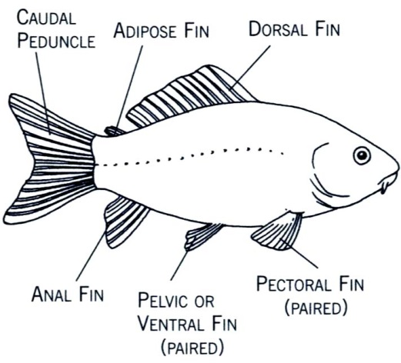

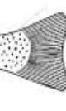
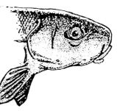
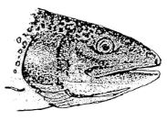
Mouth Tail Pelvic fin
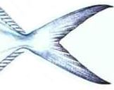
Present (V) Absent (v)

Front (F) Underside (f) Forked (T) Squared (t)

Pectoral Fins Barbels Adipose Fins
Present (P) Present (B) Present (A)
Absent (p) Absent (b) Absent (a)

Lateral Line Eyes Spots
Present (L) Large (E) Absent (Y)
Absent (l) Small (e) Present (y)

Stripes Teeth Body Color
Absent (S) Present (Z) Blue (C)
Present (s) Absent (z) Orange (c)

